National University of Lesotho
Department of Mathematics and Computer Science
CS4433 Software Engineering - Individual Final Project
Learning Management System (LMS)

Installation Guide

Deliverable for Week 6 (26-30 Oct 2026)
Phase 5: Verification and validation (12 marks); Phase 7: Deployment (4 marks)
Milestone: G3 Gate 3 - test readiness (27 Oct); M2 Release v1.0 (28 Oct)
Student: [Full name]
Student number: [Student number]
Supervisor: [Supervisor name]
Date: 28 October 2026

Table of Contents

This guide installs the LMS on one school computer. No internet connection is needed to install or use it.
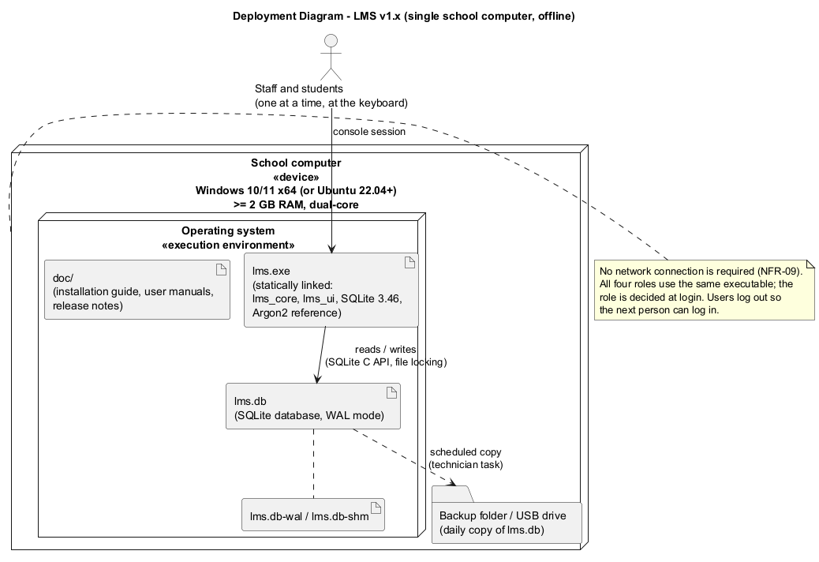

1. What you need
- A computer with Windows 10 or 11 (64-bit), at least 2 GB RAM and 100 MB free disk space. (Ubuntu 22.04 or later also works; see section 7.)
- The release file LMS-1.x.x-Windows.zip (from the GitHub release page or a USB stick).
- A USB drive or second folder for backups.
- About 20 minutes.

2. Install
- Log in to Windows with an account that can create folders on drive C:.
- Create the folder C:\SchoolLMS.
- Copy the ZIP file into C:\SchoolLMS and extract it (right-click > Extract All... > Extract). You now have:
C:\SchoolLMS\bin\lms.exe
C:\SchoolLMS\doc\ (this guide, the user manuals and the release notes)
- Create a data folder: C:\SchoolLMS\data.
- Create a desktop shortcut:
  - Right-click the desktop > New > Shortcut.
  - Location: C:\SchoolLMS\bin\lms.exe --db C:\SchoolLMS\data\lms.db
  - Name: School LMS.
  - Right-click the new shortcut > Properties > Start in: C:\SchoolLMS\data > OK.
- Protect the data folder so that only the technician's Windows account and the LMS can change it: right-click C:\SchoolLMS\data > Properties > Security, and remove "Users: Modify" if your school's policy allows. Students must not be able to copy lms.db.

3. First start (create the administrator)
- Double-click School LMS. A black text window opens.
- The program says "First run: no administrator account exists."
- Type a username for the administrator (e.g. admin), the full name, and a password (at least 8 characters with letters and digits). The password is not shown while you type, which is normal.
- Choose 1 to log in with the new account. You now see the Administrator menu.
- Give the administrator account details to the person who will manage users (see the Administrator manual).
To check the version: open Command Prompt and run C:\SchoolLMS\bin\lms.exe --version.

Optional: demonstration data for training
To practise before real use, start the program with a separate database:
C:\SchoolLMS\bin\lms.exe --db C:\SchoolLMS\data\training.db --seed-demo
Every demo account (admin, hod.sci, lect.sci, stud1...stud5, ...) uses the password Passw0rd2026. Never use --seed-demo on the real database.

4. Daily backup (important)
All school data is in one file, C:\SchoolLMS\data\lms.db.
- At the end of each day, make sure nobody is using the LMS (the window is closed).
- Copy lms.db (and lms.db-wal if it exists) to the backup drive into a folder named with the date, e.g. E:\LMS-backup\2026-10-15\.
- Keep at least the last 10 daily copies and one copy per month.
Automatic option: Windows Task Scheduler > Create Basic Task > daily at 17:30 > Start a program robocopy with arguments
C:\SchoolLMS\data E:\LMS-backup\latest lms.db lms.db-wal.
Restore: close the LMS, copy the backup lms.db back into C:\SchoolLMS\data, delete any lms.db-wal and lms.db-shm there, start the LMS.

5. Upgrading to a new version (e.g. 1.0 -> 1.1)
- Make a backup (section 4).
- Extract the new ZIP over C:\SchoolLMS (replace files when asked). The data folder is not touched.
- Start the LMS. The database is upgraded automatically the first time; the program refuses to open a database created by a newer version, so you cannot accidentally downgrade.

6. Things you must not do
- Do not put lms.db on a network share or open it from two computers at once. The system is designed for one computer; SQLite files can be damaged over network shares.
- Do not edit lms.db with other tools. The audit table refuses changes, and editing other data bypasses the school's rules.
- Do not change the computer's date and time. Deadlines and late penalties depend on the correct time.

7. Linux (Ubuntu) installation
sudo apt install build-essential cmake git
git clone <repository-url> lms && cd lms
cmake -S . -B build -DCMAKE_BUILD_TYPE=Release -DLMS_BUILD_TESTS=OFF
cmake --build build
sudo install -m 755 build/app/lms /usr/local/bin/lms
mkdir -p ~/lms-data && lms --db ~/lms-data/lms.db

8. Troubleshooting
Message / problem | Cause | What to do
Fatal error: Cannot open database ... | Folder does not exist or no permission | Create C:\SchoolLMS\data; check the shortcut's --db path and folder permissions
The database was created by a newer version of the LMS | An old lms.exe was started on an upgraded database | Install the newer version
This account is temporarily locked | 5 wrong passwords | Wait 15 minutes, or the administrator uses Reset a user's password
Window closes immediately | Started without the shortcut, or the database path is wrong | Run from Command Prompt to see the message
Deadlines look wrong by hours | Wrong time zone or clock on the PC | Correct Windows date/time settings

